Database creation

By Mohamed Firas Faisal

# Content

**Content** **2**

**Requirements** **3**

**Entity relationship diagram** **4**

**Making the database in MYSQL** **5**

Creating Database: 5

Creating the tables inside the database: 5

# Requirements

The requirements of this project is to create a database for a small cafe that handles dine in and takeaway.

Functional requirements

Data storage and management:

Store and manage:

Menu items (name, price, description, ingredients, categories)

Inventory (ingredients, stock levels, reorder points)

Sales transactions (orders, payments, discounts, voids)

Customer information (name, contact, purchase history,)

Employee information (name, contact, schedule, wages)

User requirements

Easy data retrieval

Comprehensive search and filtering

Flexible data manipulation

# Entity relationship diagram

This is the Entity Relationship diagram of the database of the cafe

# Making the database in MYSQL

## Creating Database:

Create the database using the create function:

## Creating the tables inside the database:

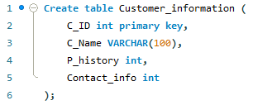

Create all the tables by defining the field names and their respective data types.

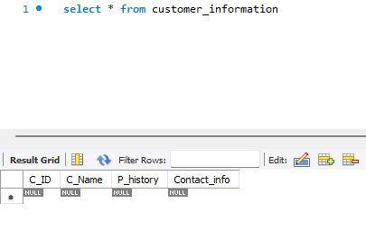

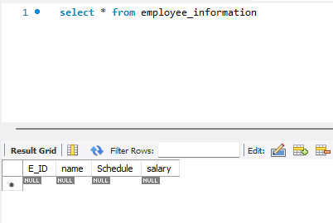

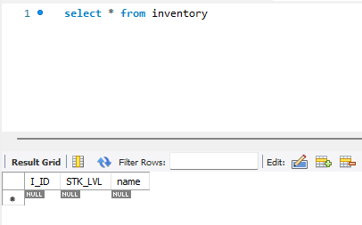

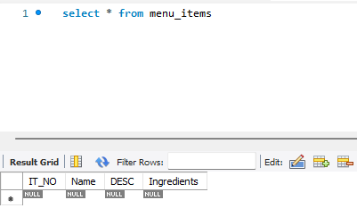

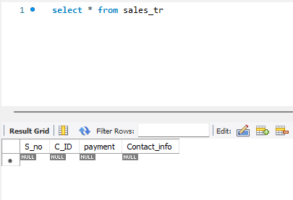

Now that all of the tables in the database have been created the management can begin to input data into the tables.

They can either choose to use Code to input the data into the tables or use the GUI to input the data they need into the tables.

Normalsing data into the tables